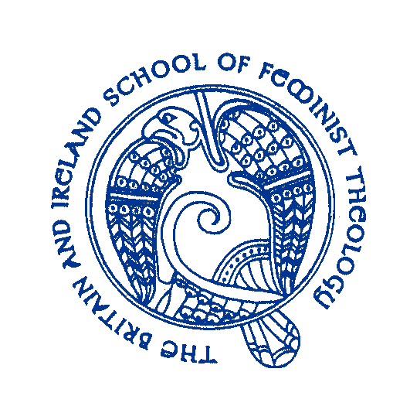

**BRITAIN AND IRELAND SCHOOL OF FEMINIST THEOLOGY**

**SUMMER SCHOOL 2020**

Tuesday 16th June to Thursday 18th June 2020

At University of Wales, Trinity St David, Lampeter, SA48 7ED

**Ecofeminist Theologies In the Age of Climate Crisis.**

Our keynote speakers are: Prof Heather Eaton, [St Paul, University, Ottawa], Prof Agnes Brazal, [DeLa Salle University, Manila], Prof Catherine Keller, [Drew University, USA], Kara Moses [Re-Wilding, Cymru]. Dr Megan Clay will discuss the art exhibition entitled ‘Women Dancing with Gaia’.

**Cost: £190** inclusive of B&B, lunch, evening meal, teas and coffees throughout the day and conference fee. All meals will be vegetarian

Daily Rates: Full days £60 including lunch; Half Days £30

**Early Bird Booking before 15th April, £175.**

**Closing date for all bookings 30th May 2020.**

*If you offer a seminar paper or workshop there is a £40 fee discount for full board participants and £10 fee discount for daily participants. All papers will be considered for publication in the international journal ‘Feminist Theology’.*

For further information contact: Professor Lisa Isherwood <mailto:>lisherwood@uwtsd.ac.uk

…………………………………………………………………………………………………………………………………………………………….

Booking Form: [Please return this form whatever payment method you use]

Name

Address

E-Mail

Full Attendance Tuesday only Thursday Only

Food Allergies……………………………………………………………………….

Payment by cheque to BISFT, The Lodge, Cook Rees Ave, Neath SA!! 1JT or by BACS transfer Britain & Ireland School of Feminist Theology Sort Code 16-2464 Account 11265608. Your name as reference.