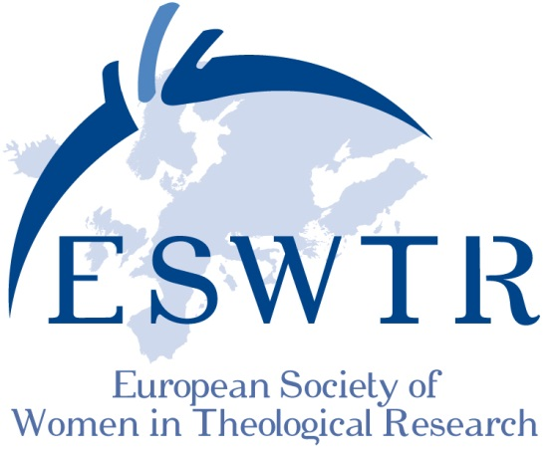

**TRANSLATION - TRANSGRESSION - TRANSFORMATION**

International Meeting of the ESWTR August, 23 – 26 2017, Vienna, Kardinal-König-Haus

Preliminary program (July 2016)

Opening address: Wednesday August 23, 7pm

Regina Polak (Pastoral Theology/ University of Vienna):

**Dreams and Border Crossing Realities and Experiences of Migrating Women**

|  |  |
| --- | --- |
| Thursday, August 24 2017 **Crossing Interreligious Borders** | |
| 09.00-10.00 | Judith Gruber (Intercultural Theology / Loyola University)  **Theology after the Cultural Turn** |
| 10.00-11.00 | Catherine Cornille (Boston)  **Theology of Interreligious Dialogue** |
| 11.00-11.30 | Pause /Break |
| 11.30-13.00 | Subject groups (call for papers) |
| 13.00-15.00 | Lunch break  3 Parallel Panel sessions with each time two panel members in dialogue |
| 15.00-16.30 | 30 minutes per panel member with concluding discussion with the audience |
|  | 1. **Jewish-Christian Dialogue**   * Birgit Klein (Jewish Studies, Hochschule für Jüdische Studien, Heidelberg) * Irmtraud Fischer, Edith Petschnigg (Old Testament, University of Graz) |
| page2image1880 | 2. **Jewish-Muslim Dialogue**   * Amina Nawaz (Islamic Theology, University of Tuebingen) * Merav Rosenfeld-Hadad (University of Cambridge)   3. **Christian-Muslim Dialogue**   * Zilka Spahić-Šiljak (Sarajevo, Bosnien -Herzegowina) * Anja Middelbeck-Varwick (Systematic Theology, Free University of Berlin) |
| 18.30 | Dinner |
| 20.00 | Encounter with **"Sara, Hagar and Magdalena"** from the afternoon sessions |
|  | |
| Friday, August 25 2017 **Crossing Biblical Borders** | |
| 09.00-10.00 | Madhavi Nevader (St. Andrews University/ Scotland)  **Transformation of Deities in Ancient Near Eastern and Biblical Studies** |
| 10.00-11.00 | Hanna Tervanotko (University of Helsinki)  **The Transformation of Miriam** |
| 11.00-11.30 | Break |
| 11.30-13.00 | Parallel Sessions with each time two panelists in Dialogue   1. **Social and religious changes in biblical studies** (Old Testament)   Mercedes Navarro Puerto (Spain)  Carmen Bernabé-Ubieta (Universidad de Deusdo, Spain)   1. **Social and religious changes in biblical studies** (New Testament)   Silke Petersen (University of Hamburg)  Marlis Gielen (University of Salzburg) |
|  |
| 13.00-14.30 | Lunchbreak with time for meetings |
| 14.30-16.30 | ESWTR General Assembly |
| 16.30 | Cultural and social activities |

|  |  |
| --- | --- |
|  | |
| Saturday, August 26 2017 **Crossing Borders in Ethics** | |
| 09.00-10.00 | Marta López Alonso (Madrid)  **Care as Basic Principle in Bio-ethics** |
| 10.00-11.00 | Valeria Ferrari-Schiefer (Fachhochschule Gesundheit und Soziale Arbeit, Switzerland)  **Considering the End of Life from the Perspective of Care-ethics** |

|  |  |
| --- | --- |
| 11.00-11.30 | Break |
| 11.30-13.00 | Parallel sessions with each time two panel members in dialogue  1. **Borders  in Bio-ethics**   * Angelika Walser (University of Salzburg, Theological Ethics): Experiencing the Borders and Demarcation of Borders as Basic Themes of a Theological Ethics? * Fatma Aydinli (Universität Frankfurt am Main, Ethik):   Asking Questions at the End of Life  2. **Transformation in Bodies**   * C.A.M. van den Berg (University of Utrecht):   Transformation in Bodies   * Gertraud Ladner (University of Innsbruck):   Transformation in Bodies |
|  |
| 13.00-15.00 | Lunch break |
| 15.00-16.30 | Subject groups (call for papers) |
| ab 16.30 | Ritual conclusion, dinner and party |

Sunday, August 27 2017 departure

**Times reserved for individual group meetings:**

Wednesday, 23 August at 5 pm: ESWTR Contact Women

Thursday 24 August at 2 pm: preparatory work for the AGM

Thursday 24 August at 5 pm: meetings in country-groups